Objective: After completing this laboratory session the student will be able to use Pathfinder.

Procedure: Use Pathfinder to calculate the evacuation time of the following building. You must submit an answer to the question (total evacuation time), the reasoning for your choice of movement speeds (do not use the default values), the reasoning for your selected occupant load, and your .pth file.

* Library with sides of 10 m by 12 m
* 3 stories tall- Bottom two floors are stacks and the top floor is used for meeting space and reading areas.
* Two stairs at opposite corners (use dogleg stairs for mid height landing)
* One internal stair
* Two ground floor exits
* People randomly located on floors
* Uniform distribution of speed (minimum and maximum values should be different)

Note: Each student must submit their own work.

**Total evacuation time**

87.8s

**Movement Speeds**

According to Kuligowski (Kuligowski, Peacock, & Hoskins, 2010) and SFPE (Society of Fire Protection Engineers, 2019), the moving speed of people in fire is complied in Chapter 64 of the SFPE Handbook of Fire Protection Engineering.

Throughout Table 64.14 and Table 64.15, it can be founded the travel speed and delay time derived from peer-reviewed articles and incident reports. In the given case, the scenario is regarded as public space, thus the min and max range of the speed is 0.51 and 1.25 m/s.

**Selected Occupant load**

The net area for each floor is 10 times 12 meters equals to 120 square meter, which is 1292 sq.ft

The first and second floor in the building is used as the stacks while the third floor is used for meeting places and reading areas.

According to International Building Code(2018 Version) (International Code Council, 2018), Table 1004.5 MAXIMUM FLOOR AREA ALLOWANCES PER OCCUPANT, the occupant load for stack area is 100 gross and that for reading rooms is 50 net.

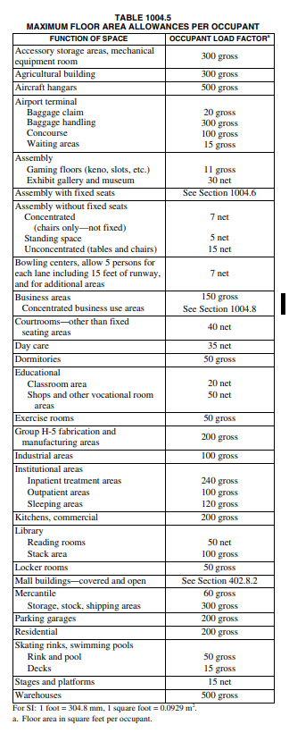

So the number of occupants in the first and second floor is 14, and that for the third floor is 27 people.

**References**

International Code Council. (2018). International Building Code. The United State.

Kuligowski, E. D., Peacock, R. D., & Hoskins, B. L. (2010). *NIST Technical Note 1680 A Review of Building Evacuation Models.* NIST.

Society of Fire Protection Engineers. (2019). *SFPE Guide to Human in Fire.*